

**INSTITUTE OF INFORMATION TECHNOLOGY**

**JAHANGIRNAGAR UNIVERSITY**

|  |  |
| --- | --- |
| Number of Project | : 01 |
| Name of Project | **: Create Shared Folder** |
| Course Tittle | **: Cyber Security** |
| Submission Date | **: 19/11/2024** |

**Submitted To Submitted By**

**Moinoddeen Quader Al Arabi**

Ethical Hacker, Forensic Investigator, and VAPT Expert Cyber Security Consultant in Dhaka Division, Bangladesh.

**Md. Shakil Hossain**

ID: 2111258

1. Setting🡪 Shared Folders 🡪 add shared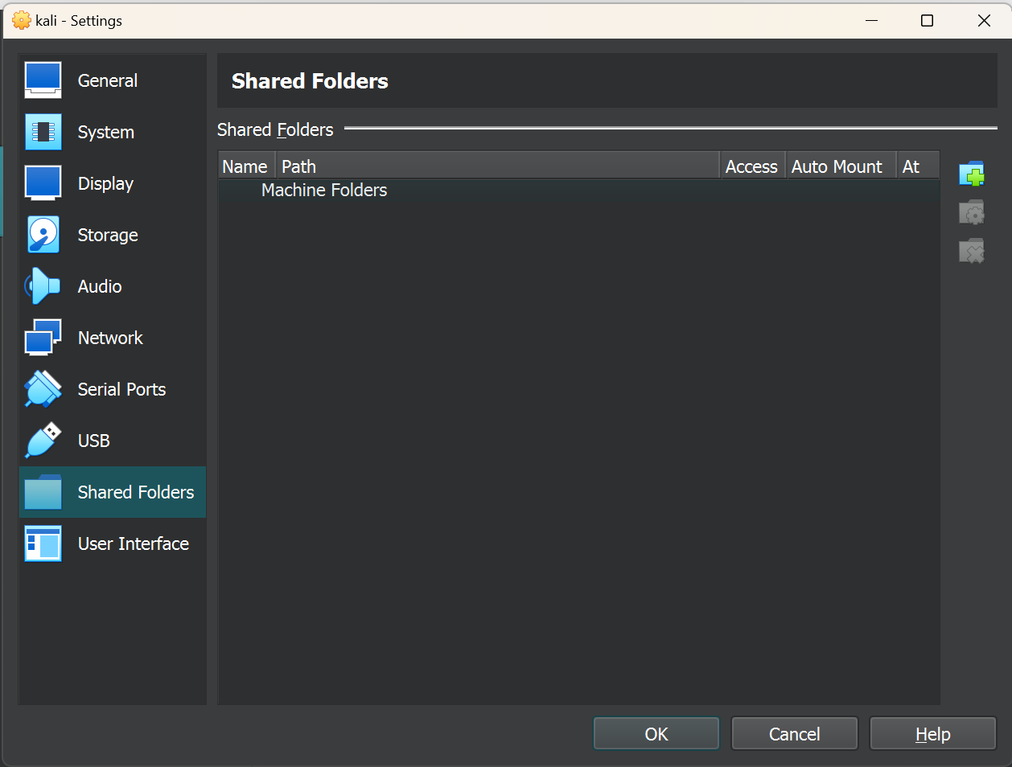
2. Folder Path 🡪 other

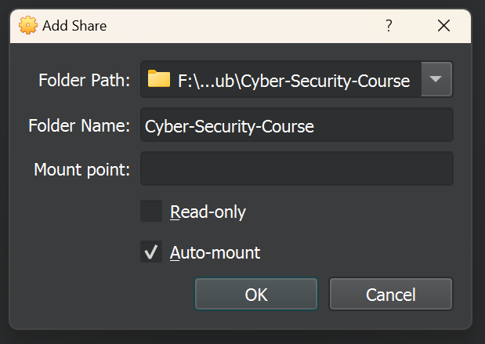

1. Terminal:

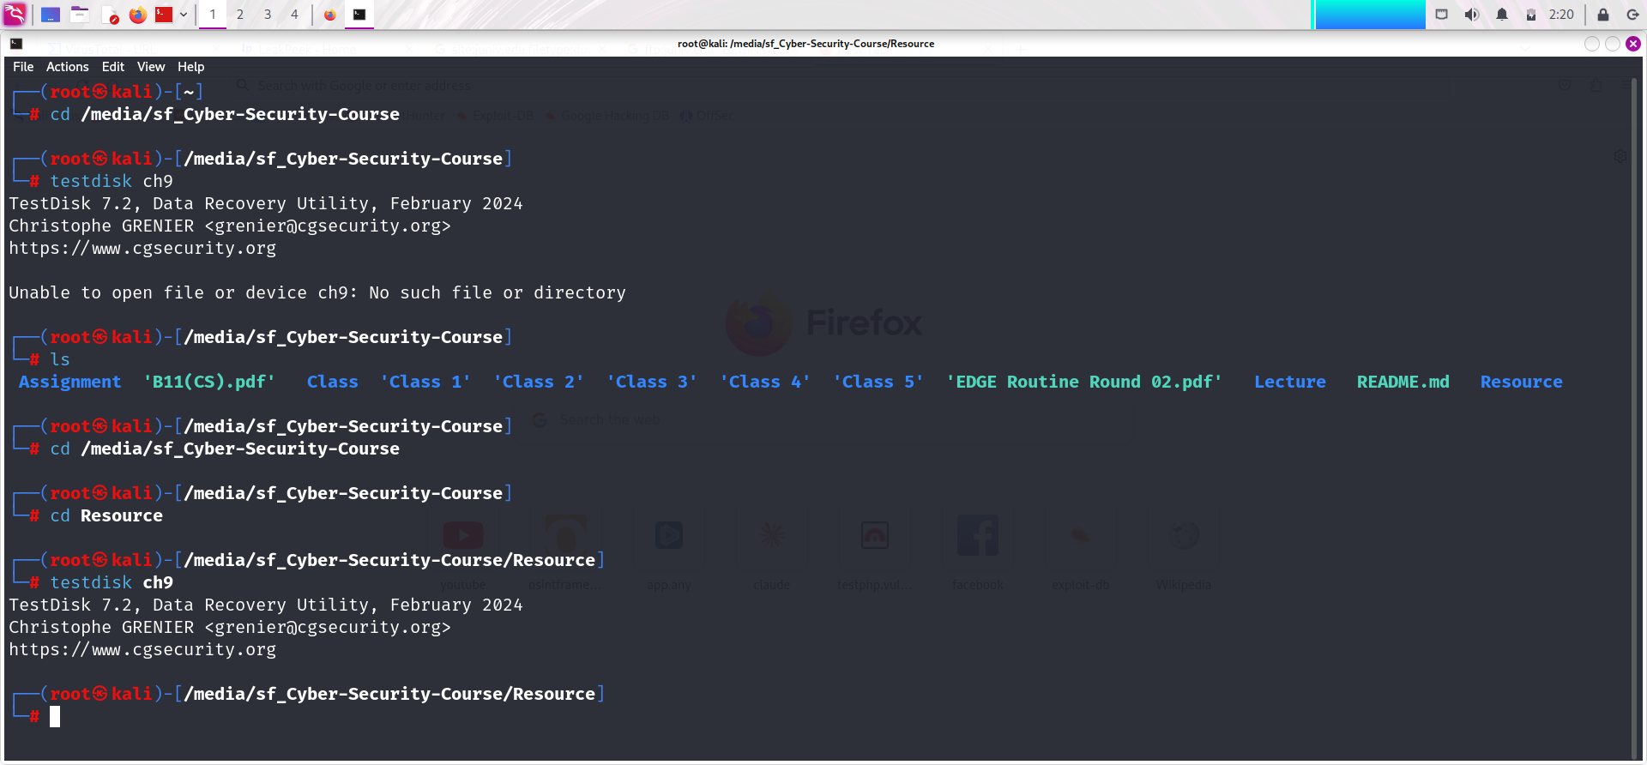

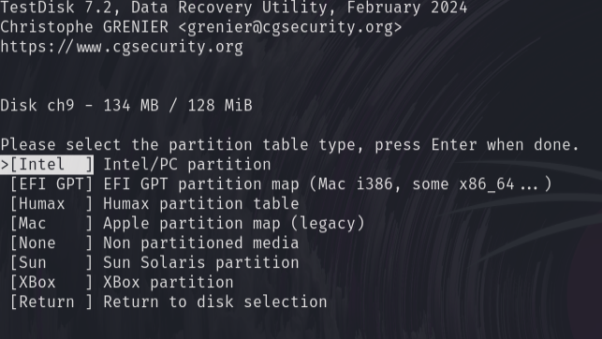

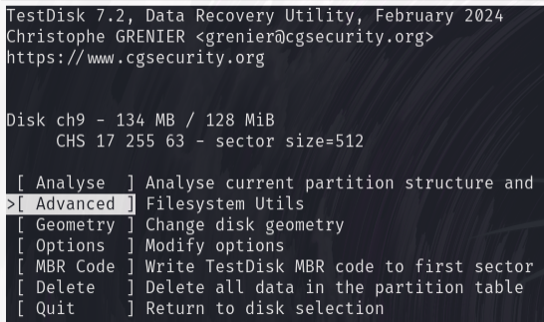

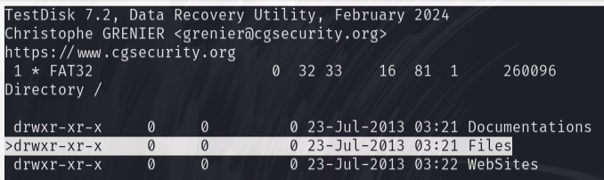

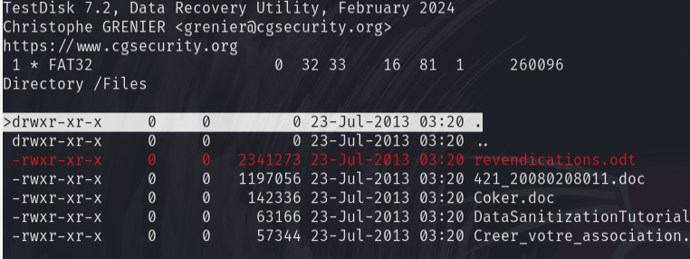

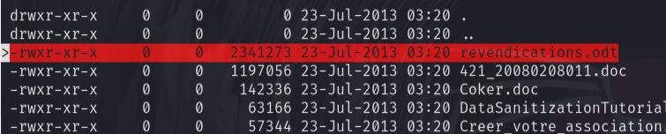

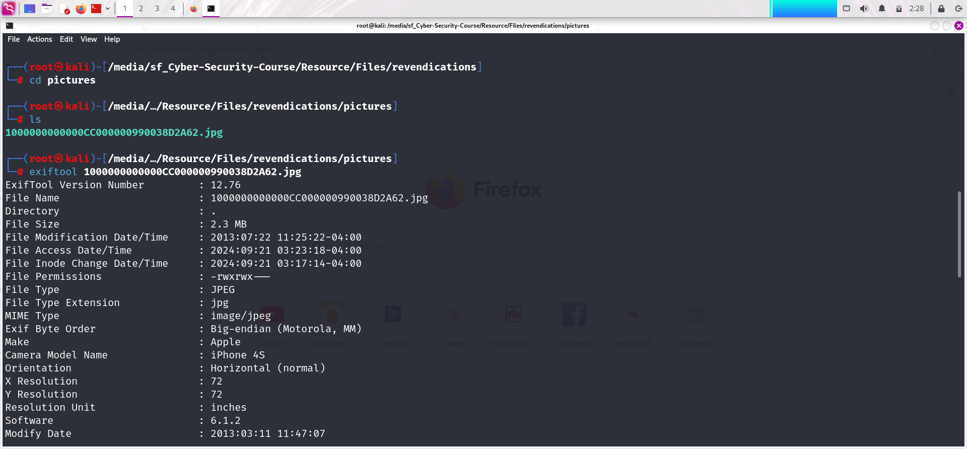

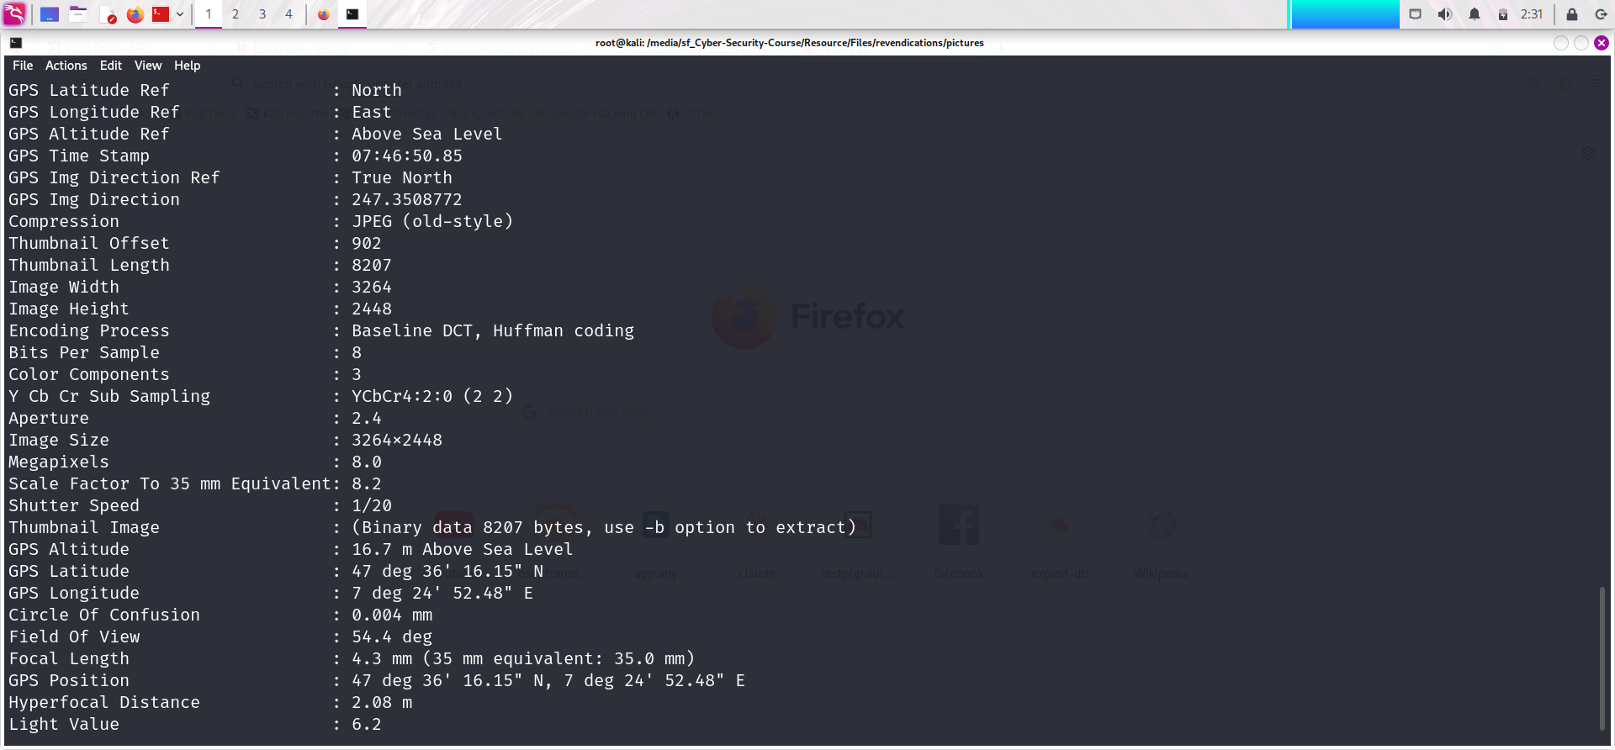

**The End**